

**Master’s Degree in Computer Science**

**Academic year 2024/2025**

**WIRELESS NETWORKS FOR**

**MOBILE APPLICATIONS**

**Prof. Claudio Palazzi**

Written by Michael Amista’

**Table of contents**

**1. Introduction on wireless communication** 3

**1.1 Current wireless systems** 4

**1.2 Emerging wireless systems** 5

**2. Physical layer** 9

**2.1 Radio frequencies** 9

**2.2 Antennas** 11

**2.3 Wireless technologies, coverage and multiplexing** 14

**3. MAC layer** 17

**3.1 ALOHA protocols** 19

**3.2 CSMA protocols** 20

**3.3 Hidden/Exposed terminal problem** 22

**3.4 802.11 protocol** 23

**4. Network layer** 33

**4.1 MANET problems** 34

**4.2 Routing protocols** 35

**4.2.1 Proactive approach** 36

**4.2.2 Reactive approach** 38

**5. Transport layer** 46

# **1. Introduction on wireless communication**

Modern wireless networks are rapidly expanding in popularity, driven by an increasing number of constantly connected devices and rising demands for higher data rates. This trend has led to significant growth in Wi-Fi technologies and cellular generations (3G, 4G, 5G, and soon 6G) alongside the rise of applications requiring both low and high data throughput.

Wireless technology is now embedded in various interdisciplinary applications:

* **Continuous data modification and upload**: social media platforms, for example, enable users to frequently update and share new content (Web 2.0).
* **Multi-reality experiences**: enabling diverse immersive environments (AR/VR/MR/tele-presence).
* **Ultra responsive to our touch**: enabled by ultra-low latency and high availability (tactile Internetprovides instant feedback to touch, enabling real-time, responsive interactions).
* **Real-time connectivity across diverse data demands**: devices communicate and gather data continuously.

Future wireless networks aim to enable seamless, ubiquitous communication between people and devices, facilitating wireless access and cellular connectivity everywhere, often with intelligent data services and network infrastructure. Achieving this vision requires careful attention to constraints like bandwidth, latency, energy consumption, and connectivity.

Designing these networks presents several challenges:

* **Wireless channels are complex and capacity limited**. Unlike wired networks, wireless channels face unique constraints: interference, error rates, delay, and nominal speed are key factors to consider.
* **Network planning is challenging**. Factors like traffic patterns, user locations, and network conditions are in constant flux. Node positioning can vary unpredictably, complicating uniform solutions.
* **Applications impose diverse** requirements. Networks must support a variety of applications with unique demands. Some applications are delay-tolerant, while others require immediate responses, which necessitates tailored network management.
* **Energy and latency constraints affect protocol design**. Efficient traffic regulation is challenging yet essential on shared channels. Battery constraints are particularly critical in mobile devices, underscoring the need for energy-efficient solutions across network layers.

**Multimedia requirements**



Some considerations about these requirements:

* The delay in data transmission is not a crucial factor. In fact, since data is transmitted over several packets, we do not care about the delay of each single packet but instead we care about the time transmission of the whole file, which is the throughput, the total amount of time, not the delay.
* Note there is no packet loss in data transmission, this is due to the way packet transmissions are implemented, allowing to retransmit a packet when it is not received.

From these different requirements, it is obvious that **one-size-fits-all protocols and design do not work well** because each media has specific requirements. Wired networks use this approach with poor results.

In wireless network design, employing a **cross-layer design** is preferable. Unlike traditional designs where layers operate independently, cross-layer design allows for better integration and interaction across hardware, link, access, network, and application layers. This approach is especially important in wireless systems, where constraints such as delay, data rate, and energy efficiency must be balanced. By allowing layers to communicate and share information, cross-layer design improves adaptability, reduces uncertainty, and enhances robustness, ultimately leading to more efficient performance in dynamic wireless environments.

## **1.1 Current wireless systems**

**CELLULAR SYSTEMS**

A cellular system is divided geographically into cells, each cell uses a different frequency than the nearby cells, but cells that are separated by others can reuse some frequencies. Each cell is controlled by a base station, that manages the transmission and reception of signals between networks and devices.

Note on hand-off: there are means that understand if a handoff is going to happen and duplicate the communication to both antennas to keep the communication stable and then change the antenna. In this way we don't perceive anything during calls.

**WIRELESS LOCAL AREA NETWORK (WLAN)**

Wireless Local Area Networks (WLANs) connect nearby devices, typically within a range of around 100 meters, allowing them to communicate through an Internet access point. Data transmitted over WLANs is broken into packets, and devices share channel access, often using random access methods to send and receive data. While the backbone Internet provides a best-effort service, some applications, like video streaming, may experience poor performance due to the shared nature of the wireless channel and the unpredictable delays this can cause. WLANs are a popular choice for local connectivity, providing flexible and convenient access for multiple devices.

Note on the “real” throughput: the nominal Mbps shows the maximum amount of data that can be received in our device, the subscription to an operator determines the correct amount of data that can effectively be received.

**SATELLITE SYSTEMS**

Satellite systems provide coverage over very large geographical areas and operate at different orbit heights, with geostationary satellites (GEOs) at around 39,000 km and low-Earth orbit satellites (LEOs) at around 2,000 km. These systems are typically optimized for one-way transmissions, such as radio and television broadcasting.

**BLUETOOTH**

Bluetooth is a low-cost, radio frequency (RF) technology primarily designed for replacing cables in short-range communication. Typically, it operates within a range of 10 meters, though it can be extended up to 100 meters through multihop connections. Bluetooth uses the crowded 2.4 GHz frequency band and supports one data channel with speeds up to 700 Kbps, along with three voice channels. It is widely adopted across industries, including telecommunications, personal computers, and consumer electronics. However, beyond its use as a cable replacement, Bluetooth has relatively few applications, limiting its broader utility.

## **1.2 Emerging wireless systems**

**AD-HOC NETWORKS (ANETs)**



They have a *peer-to-peer* communication architecture, devices communicate with each other without relying on an intermediary (AP or router). Routing can be multi hop to extend area of coverage or to reduce interference devices can pass the data between each other to reach a further destination. Devices in an ad-hoc network automatically discover and connect with other devices in range, they automatically create routes to reach the other devices (a device when part of an ad-hoc network broadcasts its presence to other devices to build a route). They topology is dynamic, it can change frequently (devices join or leave without requiring manual configuration). In an ad-hoc network there is not a communication with the internet, the aim is to create a really close network.

It was created in the military field, now they provide a flexible infrastructure for many emerging applications. The capacity of such networks is generally unknown, it depends on how many nodes are part of that network, on the interference, transmission available, how much area they cover. All the strategies (transmission, access, routing) that are used in these networks are ad-hoc. Energy constraints are very important because the devices (nodes) that are part of the ad-hoc network consume battery (usually we are talking about phones or sensor, with vehicles there is not this problem).

**MESH NETWORKS**



They can be seen as an ad-hoc extension of a WiFi in an urban infrastructure. The aim is to create a low cost, high performance wireless coverage. Here is possible to have multiple routers that are connected to different access point wirelessly, this way WiFi coverage can be extended to very large areas without the need to use wired connections between access points. An example could be that there are a few routers (more specifically modems) connected to the internet through cable, and then more routers (mesh nodes) are wireless, and they extend the coverage of the signal in large areas. Unlike traditional networks that rely on a single central router or switch, mesh networks do not have a single point of failure. This allows for improved redundancy and coverage. This means if one node fails or goes offline, data can be rerouted through other nodes.

The main challenges are finding routing protocols to achieve load balancing, QoS, efficient autonomous operations when the infrastructure fails.

**SENSOR NETWORKS**

This is a specific type of ad-hoc network nodes are sensors used to monitor specific aspects. A sensor can collect data from the environment and send the information back to the central system for analysis and action. Sensor communicates wirelessly. When a sensor collects data and process it, it sends the data to a central node called sink or base station (centralized location) where it can be analysed, this communication can happen through multi hop communication. Sensors are powered up by batteries or energy harvesting methods, to minimize power consumption. Note that here the driving constraint is the energy.

**DISTRIBUTED CONTROL NETWORKS**

These are systems designed to control operation across devices and sensors. The nodes that are part of these network perform their specific task, they communicate with each other in a P2P fashion or another way depending on the network architecture. In these systems some distributed control algorithms are implemented to enable the collaboration between nodes. Each node can apply some decision making by performing certain actions.

**MOBILE AD-HOC NETWORKS (MANET)**

A type of network that establishes wireless communication in dynamic and decentralized environments. In this case the nodes (mobile devices) communicate with each other without the need for centralized control (router or AP). The difference between an ad-hoc network and a MANET is just the emphasis that the nodes are mobile devices (they keep moving), just ad-hoc is a little more static because I can have cabled nodes. This kind of networks are mainly created to satisfy a temporary need, are easily deployable and re-configurable.

**OPPORTUNISTIC AD-HOC NETWORKS**

These are a specific type of ad-hoc networks, nodes communicate opportunistically, they operate in environments where nodes may not always be in direct communication range, so when two nodes come within contact, they can exchange data before they move apart again. Here nodes store data until they encounter another node that can help move that data to a closer destination (store carry forward paradigm). The routing is called opportunistic because data forwarding decision are based on the contacts that occur between nodes, they decide dynamically when to send data.

**VEHICULAR AD-HOC NETWORK (VANET)**

A specialized form of MANET, designed for communication between vehicles. This Networks aim to improve road safety, traffic efficiency. The communication must be really fast, it must have low latency.

**FLYING AD-HOC NETWORK (FANET)**

A specialized form of MANET, designed for communication between aerial vehicles such as drones. Here drones can communicate with each other, and possibly with ground stations or other infrastructures.

**UNDERWATER NETWORKS**

These networks consist of various interconnected underwater sensors and vehicles deployed in water (oceans, lakes, rivers) to perform tasks like environmental monitoring, disaster prevention. Unlike terrestrial sensor networks, underwater networks face unique challenges due to the properties of water, such as higher communication latency, limited bandwidth, and energy constraints. In this case the medium that transports data is sound (acoustic waves), radio wave are attenuated in water, that’s why they are used in shallow water. This kind of communication has significant latency, and that is because sound waves propagation in water is a lot slower than electromagnetic waves propagation in the air. Also, the available bandwidth for sound is much narrower compared to the terrestrial wireless communication and that makes difficult to send large amount of data.

**RADIO FREQUENCY IDENTIFICATION (RFID)**

RFID technology is used to identify and track objects and consists of three main components: RFID tags, readers, and a backend system. RFID tags, which can be attached to objects, contain microchips to store data and an antenna for communication. Tags can be passive (no internal power, activated by the reader's electromagnetic field, and have limited range) or active (powered by their own battery, allowing longer-range communication). RFID readers, either fixed or mobile, emit radio waves to communicate with the tags. When a passive tag comes within range, the reader activates it, and the tag sends its data. Active tags continuously transmit signals. The backend system (a server) processes, stores, and analyses the data received from the readers. RFID operates on different frequency bands, each suited for specific uses, like scanning items in a store instead of barcodes, where tags provide detailed product information.

**NANO NETWORKS**

They refer to communication networks at the nanoscale that consist of nano-sized devices or machines (often referred to as nanomachines) that are able to interact and communicate with each other. Traditional electromagnetic-based communication techniques are often unsuitable for devices at such small scales due to power and size constraints. Instead, communication in nano networks could rely on novel communication paradigms such as molecular communication or terahertz-band communication.

# **2. Physical layer**

## **2.1 Radio frequencies**

Radio frequencies (RF) refer to the range of electromagnetic waves that are used to transmit and receive information through the air without the need for physical connections like wires or cables. These frequencies range from 3 Hz to 300 GHz, covering everything from very low frequency (VLF) radio waves to extremely high frequency (EHF) microwaves. Electromagnetic energy is generated by high frequency alternate current (AC) in antennas where is converted into RF and vice versa. RF are fundamental for wireless communication.



The **amplitude** of the wave (measured as the difference between the highest and lowest peak) is the energy the wave carries, is varied in proportion to the information being transmitted. The greater the amplitude the more energy the waves carry. The higher is the amplitude the further the signal goes. Amplitude depends on the transmission medium (air, outer space, etc.). The transmission power is measured in Watts = Energy / Time = Joule / Sec.



The **frequency** of a wave refers to the number of complete oscillations of the wave that occur in a specific amount of time, typically measured in **hertz (Hz).** The higher the frequencythe more information is transmitted, but it’s difficult to penetrate objects, with lower frequencies have longer wavelengths and can travel longer distances and penetrate objects (penetration can weaken the signal). Frequency allows two nodes to hear communications each other, if both are set on the same frequency value. It is a portion of wireless spectrum assigned to wireless technologies by regional authorities.



The **phase** of a waverefers to the position of a point in time on the wave cycle, indicating the specific stage of the wave's oscillation. It describes the relative displacement between different points of a wave or between two waves of the same frequency. It is the shift of a wave in degrees or radians. The phase can be positive (left-shift) or negative (right-shift).



The **polarization** (physical position of the antenna) refers to the orientation of the electric field in an electromagnetic wave. Polarization can be horizontal if the electric field oscillates parallel to the ground, vertical if the electric field oscillates perpendicular to the ground. Vertical polarization is typically used in WLANs, the antennas must be placed parallel to each other (otherwise less signal is received). RF waves are made of two fields, *electric* that is parallel to the antenna and *magnetic* filed that is perpendicular.



* 1. **Propagation** determines the RF coverage of the signal (how far it can go). After a certain point the signal is no longer detectable It depends on the strength of the signal itself. Signals become weaker in an exponential decline. Propagation ranges depends on power, obstacles, receiver’s sensitivity and many factors. It is quite useful to consider the following ranges of RF detection:
* *Transmission range* = how far the communication reaches. Communication possible, low error rate.
* *Detection range* = how far can the signal be found. Detection of the signal is possible, no communication possible via exchanging messages.
* *Interference range* = the distance at which the signal is too far away from the sender to be detected. Signal may not be detected.
  1. Remember that obstacles can reflect or absorb waves, and it depends on material and frequency used. In general, remember the following rule of thumb:
     + **high frequencies = good for short distances/more affected by obstacles**. They get weaker faster at some point the signal cannot be read anymore.
     + **low frequencies = good for long distances/less affected by obstacles**. These signals remain more readable over long distances.

The **receiving power** is proportional to 1/d2 where d = distance between sender and receiver. The receiving power can be influenced by different factors, such as:



**Multipath propagation:** signals can take many different paths between sender and receiver due to phenomena like reflection, scattering, diffraction.

**Time dispersion** happens when the signal is dispersed over time, it can happen that a signal is scattered into more signals, and some of those annihilate each other. The receiver ends up getting a really bad signal. We use Decibel (dB) as a power measurement to express power loss.

## **2.2 Antennas**

Antennas are devices that transmit and receive electromagnetic waves, enabling communication between devices over a distance, such as radio, TV, cellular, and Wi-Fi systems. They work by converting electrical signals into electromagnetic waves for transmission and vice versa for reception. During transmission, an antenna converts electric signals (which carry information, like voice or data) into electromagnetic wavesthat can travel through the air. This is achieved by applying an alternating current (AC) signal to the antenna, which generates oscillating electric and magnetic fields.

The size of antenna is related to RF frequency of transmission and receptions, the shape is related to RF radiation pattern. Is important also to notice that antennas are positioned with the aim of reach maximum area coverage.

Real antenna types are: omni-directional, semi-directional, highly-directional.

**OMNI-DIRECTIONAL ANTENNA**



A type of antenna that radiates electromagnetic signals uniformly in all directions around the vertical axis. It is commonly used in situations where coverage in all directions is needed, such as for radio stations, Wi-Fi routers, mobile networks, and some types of broadcast communication, outdoor with point to multipoint connection. Examples of this type of antenna can be the **dipole antenna,** two equal-length conductive elements (usually metal rods or wires) arranged in a straight line. These elements act as the radiating and receiving structure for electromagnetic waves. The dipole antenna has a passive gain due to the shape of radiation. **Gain** measures how well an antenna can focus energy on a particular direction.

**SEMI-DIRECTIONAL ANTENNA**



A type of antenna that focuses the radiation of electromagnetic signals in a specific direction (a specific sector), but not as narrowly as highly directional antennas. Semidirectional antennas are often used in applications where moderate coverage over a specific area or in a certain direction is required. Examples are Patch/Panel Antennas that are flat antennas mounted on walls, or Yagi that are rods with tines sticking out.

**HIGHLY DIRECTIONAL ANTENNA**



Focus the transmission and reception of radio waves in a very narrow and specific direction. This allows them to achieve greater signal strength and range over long distances compared to omnidirectional or semidirectional antennas. These antennas are used in applications where precise point-to-point communication or long-distance signal transmission is required. Example are the Parabolic dish or the grid.

**LOS (Line of Sight):** is the unobstructed path (a straight line) between transmitter and receiver.



**Fresnel Zone**: describes the elliptical region around the direct line-of-sight (LOS) path between a transmitter and receiver. It is essential for understanding how obstacles near the direct path can impact the strength and quality of a radio signal. Most additive RF signal is concatenated in the Fresnel Zone and is important that this zone is free from obstacles. The FZ radius depends on the distance between antennas and the frequency of RF.

The **beam** of an antenna describes the directionand shapeof the area where the antenna concentrates its energy. If aa FZ is partially obstructed it is not useful to use higher gain antennas, with smaller degree beam.

**SECTORIZED-DIRECTIONAL ANTENNA**



A type of antenna designed to cover a specific, limited area or sector, typically used in cellular networks, Wi-Fi networks, and other communication systems that require focused, directional coverage over a defined geographic region. These antennas divide a wide coverage area into multiple smaller sectors, each served by a different directional antenna. This enables more efficient use of radio frequency (RF) spectrum and improves signal strength within the target.d areas. They also provide space multiplexing (channel reuse).

## **2.3 Wireless technologies, coverage and multiplexing**

The **wireless spectrum** is the range of all radio frequencies used for wireless communication and that may be licensed or unlicensed.

The **bandwidth** of a wireless channel refers to the range of frequencies over which the channel can transmit data, and this range can vary widely depending on the application and environment. Wireless channels can have different bandwidths based on several factors, including the frequency spectrum being used, regulatory limitations, modulation techniques, and the specific technology or communication standard. Basically, different channels may have different bandwidth because they require less time to accommodate one bit on the channel, sending bits more frequently means making them more packed (look the figure here below).



There are different wireless technologies that influence the bandwidth:

* **Narrowband radio system** where transmission and reception are executed using a single radio frequency. Undesired cross talk between channels requires coordination and license for each site. There is low data rate.
* **Spread Spectrum technology**, used to spread a signal over a wide range of frequencies, making it less susceptible to interference, jamming, and unauthorized interception. There are two main types of spread spectrum techniques:
  + **Frequency Hopping spectrum (FHSS)**, where the signal does not stay on one frequency for long but moves across several frequencies within the band in a synchronized way known only to the transmitter and receiver. To unintended receiver FHSS appears as impulse noise.
  + **Direct Sequence Spread Spectrum (DSSS),** the signal is spread across a wider frequency band by multiplying the original data signal with a high-rate pseudo-random noise (PN)sequence, also called a chipping sequence. Each bit of data is transmitted as multiple bits called "chips," which effectively spreads the signal. To unintended receiver DSSS appears as low power Wideband noise.
* **Infrared technology** is LOS or diffused, short range. The frequencies are just below the visible light, cannot penetrate opaque objects, it allows high data-rate potential.
* **Radio Transmission Coverage** refers to the geographic area or range over which a radio signal, transmitted from a source such as a transmitter, antenna, or base station, can be effectively received. In wireless communication systems, the coverage area is the region where the transmitted signal remains strong enough for reliable communication between the transmitter and receiver. With Txwe indicate the transmission power with which the radio transmitter sends out a signal. **Symmetric links** are communication channels where the data transfer rates are equal in both directions. **Asymmetric links** are communication channels where the data transfer rates differ between the two directions.





**Multiplexing** is a technique used to combine multiple signals or data streams into a single transmission channel or medium. The primary goal of multiplexing is to make efficient use of available bandwidth by allowing multiple communications to occur simultaneously over the same physical medium, such as a wire, fiber-optic cable, or radio frequency spectrum. By using multiplexing, multiple signals can share the same channel without interfering with each other, which improves the capacity and efficiency of communication systems.

There can be different types of multiplexing:

* **Frequency Multiplexing**.The available bandwidth of the channel is divided into multiple frequency bands. A channel gets a certain band of the spectrum for the whole time. No dynamic coordination is required, it works for similar systems, it is not flexible and there is waste of bandwidth if the traffic is distributed unevenly. Each signal is transmitted on a different frequency, allowing several signals to be sent simultaneously without interference. It is used in radio and tv broadcasting.
* **Time Multiplexing**. Multiple data streams share a single channel by dividing the available time into separate time slots. Each signal is assigned a specific time slot, during which it can transmit its data. It is used in digital telephone networks, where multiple voice calls are combined over a single line. Precise synchronization is necessary, only one carrier ate the time in the medium.
* **Code Multiplexing**. Each signal is assigned a unique code. All signals (all channels) are transmitted simultaneously over the same frequency spectrum, but because each signal has a different code, the receiver can distinguish between them. It is used in mobile communication systems like 3G and GPS. Coordination and synchronization are not necessary, has a good protection against interference, has lower data rates and more complex signal generation. It is implemented using spread spectrum technology.

# **3. MAC layer**

**Multiple Access Control (MAC)** is primary responsible to manage how devices in a network gain access to a shared communication medium to avoid collisions, such as a wireless channel or a wired Ethernet network and transmit data over it.

Goals: low latency, good channel utilization; best effort + real time support.



**Channel Access Problem** arises in communication networks when multiple devices or nodes need to share a common transmission medium (such as a wireless channel or wired bus) to send data. The challenge is to ensure that devices can transmit data without interfering with each other, which could cause data collisions, leading to communication failures, delays, or packet loss. Simultaneous communication is not possible, for this reason there are several MAC Protocols that schedule communication, they maximize number of communication while ensuring fairness among all transmitters.

The simplest idea of ‘transmit and pray’, where every node sends data hoping that other nodes won’t transmit at the same time, is wrong because it causes a lot of collisions.

One of the protocols that is used to solve this problem is **Carrier Sense Multiple Access (CSMA)**, where the sender listens to the channel before sending data, it can be of two types: **CSMA/CD (Collision Detection)** for wired Ethernet: devices "listen" for an idle channel and back off in case of a collision. **CSMA/CA (Collision Avoidance)** for Wi-Fi: devices try to avoid collisions before they occur by using techniques like random backoff timers.

Collisions can still occur despite its mechanism to "sense" the channel before transmission. This is because CSMA only reduces the chances of collisions but does not eliminate them entirely. The main problem that can lead to collision is the **propagation delay** which refers to the time it takes for a signal to travel from one device to another over the communication medium. Even if a device senses the channel as idle and begins transmitting, another device located far away might also start transmitting because it hasn’t yet "heard" the ongoing transmission. This can lead to a collision, particularly in networks with larger distances between devices.

Consider the following example:

At time t0, node B initiates a transmission to node C. Observing the time axis, we can see that this transmission is not instantaneous; it takes a certain amount of time to propagate. At a later moment t1, node D also attempts to transmit. D first checks the channel, and since it appears to be free at that instant, it begins its transmission. However, due to the non-zero propagation delay of the initial transmission between B and C, D's transmission collides with the ongoing propagation, leading to a collision.



**MAC PROTOCOL APPROACHES**

**Controlled Access MAC Protocols**, where devices must coordinate with each other (or a central authority) to access the shared medium. Only one device can transmit at a time, and a predetermined control mechanism ensures that there are no collisions. They can be divided into:

* Centralized: there is an entity that is responsible to regulate the access to the channel (FDMA, TDMA, CDMA).
* Distributed: the access to the channel is controlled by a distributed application, with peer nodes (Token ring).

**Random Access MAC Protocols**, where devices transmit data whenever they have it at full channel data rate R, without a predetermined schedule or control mechanism. These protocols do not require any centralized control over the access to the shared medium. If the transmission of two or more nodes collide, they retransmit at random times. The protocols specify how to detect collisions and how to recover from them. They can be divided into:

* Without carrier sense (ALOHA, Slotted ALOHA).
* With Carrier sense (CSMA, CSMA/CD, MACAW).

## **3.1 ALOHA protocols**

**ALOHA** is a MAC protocol developed in the 70’s by University of Hawaii to have islands able to communicate to each other. Two different versions: Slotted ALOHA and Pure ALOHA.

**SLOTTED ALOHA**

Time is divided into equal slots, and devices can only transmit at the start of a time slot. This reduces the probability of collisions compared to pure ALOHA. If a collision occurs the source retransmits the packet at each slot with probability P, until successful. It is fully decentralized, in fact there is not any central authority. The throughput efficiency is 1/e, meaning that we are using less than half of available bandwidth.



Note: the main idea is to minimize as much as possible the number of empty slots, being more aggressive in transmissions, otherwise precious bandwidth is wasted. Nodes should be synchronized with time slots, otherwise there will be collisions, and this leads to more complexity to manage.

**PURE ALOHA**

This is a simpler version where devices transmit without checking whether the channel is busy, without waiting for the beginning of a slot (in fact here slots are not used). Collisions are detected afterward, and retransmissions are attempted. The throughput efficiency is worse than unslotted ALOHA: 1/2e (since there is no synchronization and looking the picture each transmission can occupy on average 2 slots, the current and next transmission one).





## **3.2 CSMA protocols**

Low performances of Pure Aloha and Slotted Aloha are due to the lack of coordination among nodes, in this case efficiency can be improved if each node behaves coherently with what other nodes do. In Carrier sense protocols each node keeps listening to the channel to be aware of what other nodes are doing.

**CSMA (Carrier Sense Multiple Access)**

CSMA is designed to reduce collisionsby requiring each device to first "listen" to the medium before transmitting. This "carrier sensing" ensures that the medium is free (i.e., no other device is transmitting) before starting a transmission, which helps minimize the risk of two devices transmitting at the same time. There are different versions of CSMA:

* **1-persistent CSMA:** "1" refers to certainty. The station will definitelytransmit as soon as it detects the channel is idle, with a probability of 1 (100% certainty). The term "1-persistent" refers to how aggressively the station checks the medium and attempts transmission once it becomes idle, in this case the state of the channel is checked continuously. The station first senses the medium to determine if it is busyor idle. If the channel is busy, the station continues to monitor the channel continuously (i.e., it "persists" in checking the medium). If the channel is idle, the station immediately transmits its data packet. If two or more stations sense the channel as idle at the same time, they will both (or all) transmit immediately, leading to a collision. If there is a collision the transmitting node/s waits for a random time and then try to retransmit again (a sort of “desynchronization” between nodes that transmit simultaneously).
* **nonpersistent CSMA**. Unlike the more aggressive 1-persistent CSMA, non-persistent CSMA takes a more conservative approach by introducing a random delay before attempting to transmit after detecting that the medium is busy. Because stations do not continuously sense the channel when it is busy, collisions are less likely in non-persistent CSMA than in 1-persistent CSMA.
* **p-persistent CSMA**. It is a slow based system, which means the network operates by dividing time into discrete slots. Stations can only transmit at the start of these slots. If the medium is idle, the station transmits the data with a certain probability p during the next available time slot. If the station doesn’t transmit (with probability 1−p), it waits for the next time slot and senses the channel again. This process repeats until the station either transmits the packet or the channel becomes busy due to another station’s transmission. The probability p represents the likelihood that a station will transmit as soon as the medium is found idle. When p is high (close to 1), the station will transmit almost immediately, similar to 1- persistent CSMA.



**CSMA/CD** enhances traditional CSMA by enabling devices to detect collisions within a few bits of transmission, allowing them to abort transmission immediately and minimize channel wastage. This approach is typically implemented with persistent transmission, where devices continuously monitor the channel and resume transmission once it's free. In wired LANs, such as Ethernet, CSMA/CD can achieve near-optimal channel utilization (approaching 1) when the propagation delay is small relative to packet transmission time. Collision detection in wired LANs is straightforward, as devices can monitor signal strength, detect code violations, or compare transmitted and received signals.

## **3.3 Hidden/Exposed terminal problem**

However, **CSMA/CD is impractical in wireless LANs**. When a device transmits a signal, it generates a significant amount of power to send data through the air. To avoid interference or potential damage from this powerful outgoing signal, the receiver circuit of the device is usually turned off during transmission. This means that, while the device is sending data, it cannot "listen" to the channel to detect if another device is also transmitting at the same time.



The SINR threshold represents the bound in which the signal cannot be detected anymore. So, when A is transmitting something, C (that is out of A’s range) cannot detect the signal sent by A since it is interpreted as “background noise”, being under SINR threshold. Once C sensed the channel and determined is idle (because it cannot hear A’s transmission), try to transmit something to B and here the collision happens.

 

In the **hidden terminal problem**, a node (C) that cannot detect a sender's (A) signal may still interfere with its receiver (B), causing collisions.

In the **exposed terminal problem**, a node (X) hears the sender's (A) signal but should not defer its own transmission to another receiver (Y), as it would interfere with the transmission in act.

## **3.4 802.11 protocol**

The Multiple Access with Collision Avoidance (**MACA**) and MACA for Wireless (**MACAW**) protocols emerged as improvements over the traditional CSMA/CD and CSMA/CA methods, particularly for wireless networks. Both protocols were developed to address key limitations in wireless communication, such as the hidden terminal and exposed terminal problems, and to enhance performance in environments where collision detection is not feasible due to the nature of wireless channels.

MACA introduced a collision avoidance mechanism that does not rely on sensing the channel during transmission (like CSMA/CD) but instead uses a handshake method based on short control messages. In response to the limitations of MACA, MACAW (MACA for Wireless) was introduced by V. Bharghavan et al. in 1994 as an enhancement to MACA, with a focus on improving fairness, throughput, and reliability in wireless communication.

These led to **IEEE 802.11** standard that defines MAC protocol; unlicensed frequency spectrum bands: 900MHz, 2.4GHz, 5GHz.

The 802.11 standard regards in particular Wireless LANs (WLANs):

* mostly indoor.
* base station (like cellular); or ad hoc networking (mostly point to point).
* standards: IEEE 802.11 (various versions); HyperLAN(ETSI); Bluetooth.



**CSMA version of the protocol**

Where the source senses the channel to see if it is idle. If the channel has been idle for a duration equal to **DIFS**, the station proceeds to transmit its data. After successfully receiving a frame, the receiving station sends an **ACK** back to the sender. This occurs after a shorter inter-frame space known as **SIFS** (shortest waiting timebetween two consecutive transmissions). The ACK ensures that the sender knows the data was successfully received, which helps avoid uncertainty due to potential collisions or packet loss. If the channel is sensed as busy (another station is transmitting), the station does not immediately try to send the frame again. Instead, it enters a **binary exponential backoff** process, which means it waits for a random period before checking the channel again.

The **NAV** is a timer set by each station to represent the amount of time the channel is expected to be busy. The sender declares the duration of its transmission(the time needed to send the frame and receive the ACK) in the frame's header. This value is used by other stations to set their NAV timers, preventing them from transmitting until the declared time has passed.

**CSMA is inefficient in presence of hidden terminal**, the solution is using CSMA/CA.



**CSMA/CA version of the protocol**

In this case we consider CSMA/CA with **RTS**/**CTS** (Request to Send / Clear to Send). RTS and CTS frames are used to freeze stations near the transmitter and the receiver, so they do not sent data while the two stations communicate. When a station sends an RTS, any station within the range of the transmitter (but not involved in the communication) hears this RTS and knows that the transmitter is about to engage in communication. These stations will "freeze" their transmissions. Stations near the receiver (which may not have heard the RTS because they are hidden from the transmitter) hear the CTS. This "freezes" them as well.



The above figure describes the actual procedure of sending data, considering also backoff values after DIFS and before RTS. In CSMA/CA, after a station senses the channel is idle for DIFS, it does not transmit immediately but instead enters the backoff phase (BOV), where it selects a random wait time before transmitting.

Anyway, here **the exposed terminal problem still occurs**.





**Use RTS/CTS** when dealing with **large data transmissions** to *avoid collisions and improve overall efficiency,* especially in networks prone to the hidden terminal problem. **Avoid RTS/CTS for** **small packets** (e.g., VoIP, gaming), as it *adds unnecessary overhead* and can slow down communication.

802.11 does not solve HT/ET problems completely, it only alleviates the problem through RTS/CTS and recommends larger CS zones. The search for the best MAC protocol is still on.





**Priorities** are managed using different **Inter-Frame Spaces (IFS)**. These are periods of time that stations must wait before they are allowed to transmit data on the wireless medium. The idea is to **prioritize certain types of traffic by giving them shorter waiting times**, allowing them to access the medium more quickly than others.



So, explaining what has been already told, when a station is ready to send data, first senses the mediumusing **CCA (Clear Channel Assessment)** to check whether the wireless channel is idle or busy. If the medium is found to be freefor a specific period called an **Inter-Frame Space (IFS)** then the device enters the backoff phase where it waits for a random drop of time (enters the **contention window**, starting with a minimum contention window CWmin). The **backoff timer** helps avoid collisions by introducing random delays between transmissions. If the medium is busywhen the station first senses it (i.e., another device is transmitting), the station must wait for the current transmission to end.



If the receiver successfully receives the packet and verifies its integrity using CRC (Cyclic Redundancy Check).If the sender doesn’t receive an ACK within a certain time, it assumes that the packet was lost (due to a collision or transmission error) and will automatically retransmit the packet after waiting for another backoff period.



Correction:after DIFS in the first line there is contention window counting time (the pink slot). In this case we are analysing the CSMA/CA with RTS/CTS. Here an additional handshake mechanism is introduced to further reduce the chances of collisions, particularly due to the hidden terminal problem. After waiting for DIFS, instead of sending the data directly, the station sends a RTSframe to the receiver. The RTS frame includes a reservation parameter, which tells all other stations how long the medium will be needed for the data transmission. If the receiver is ready to accept the data, it responds with a **CTS (Clear to Send)** frame. The CTS frame also includes the same reservation parameteras the RTS, informing all stations within range of the receiver to refrain from transmitting for the reserved duration.

**MAC-PCF (Point Coordination Function) like polling**



**MAC-PCF (Point Coordination Function)** is an optional mode in the IEEE 802.11 MAC, that provides a centralized polling mechanism for controlling access to the wireless medium. In PCF mode, the Access Point (AP) takes control of the wireless medium for a portion of the time, known as the **Contention-Free Period (CFP)**. During this time, the AP acts as a Point Coordinator (PC) and polls the stations (nodes) to check if they have data to send. The **stations do not compete for access**; instead, they are polled in turn by the AP. The AP sends a poll frame to a station, which grants that station **exclusive access to the medium for a short time** to transmit data. The station replies with data (if it has any), and the process repeats for other stations.

The Access Point (AP) periodically broadcasts **beacon frames**. These beacons contain information about the network, including whether the AP supports PCF. Stations (nodes) in the network use the beacons to discover nearby APs and learn more about the network characteristics. Before a node can fully connect to an AP, it must first authenticate itself to the AP, and the AP must authenticate itself to the node. Once authentication is successful, the node needs to associate with the AP to formally join the network. The node sends an association request management frame to the AP. The AP responds with an association response. In the association/reassociation frames the node announces to the AP whether it is pollable and capable to transmit during the contention free period (CFP).

**SYNCHRONIZATION IN 802.11**

**TSF (Timing Synchronization Function)** is a mechanism used in IEEE 802.11 wireless networks to keep all devices (stations) synchronized to a common clock. TSF is crucial for maintaining proper timing in operations like frame coordination, power-saving modes, and the scheduling of contention-free periods (CFP) in networks that use the Point Coordination Function (PCF).

Infrastructure Beacon Generation refers to the process by which an Access Point (AP) periodically sends beacon frames to announce its presence and provide crucial network information to connected stations (devices) and those looking to join the network. **Beacon Interval**: the time between two consecutive beacons, typically 100ms by default.

**POWER MANAGEMENT APPROACH**

Power Managementin IEEE 802.11 wireless networks (Wi Fi) is a mechanism designed to reduce power consumption for devices. The power management approach **allows devices to enter sleep mode** when not actively transmitting or receiving data, while still maintaining a connection to the network. When a station is in power-saving mode and cannot receive data immediately, the AP will buffer any incoming unicast frames for that station. The **station periodically wakes up** at specified intervals to listen for beacon framesfrom the AP. The AP includes TIM (Traffic Indication Map)information in the beacons to indicate which stations have buffered data waiting at the AP. If the beacon shows that there is data waiting, the station sends a PS-Poll frame(Power-Save Poll) to the AP to request the buffered data. If the beacon shows no pending data for the station, the station can return to sleep.

**SCANNING**

Scanning refers to the process used by stations (client devices) to discover available wireless networks and their characteristics. There are two main types of scanning: **Passive Scanning** and **Active Scanning**. Both methods are utilized by devices to find access points (APs) and assess the network environment.

In passive scanning, the station listens for beacon frames broadcasted by nearby access points. In active scanning, the station actively sends out probe requests to discover nearby access points. APs that receives these requests respond with probe responses.



**CONGESTION AVOIDANCE: IEEE 802.11 DCF**

The Distributed Coordination Function (DCF) is the fundamental access method for handling congestion avoidance in wireless networks. The key mechanism to avoid collisions when multiple stations try to access the same channel is through a **random backoff** process, which helps ensure that no two stations transmit simultaneously. Before a station can transmit a data packet (or a Request to Send (RTS) frame), it must select a random backoff interval to avoid collisions with other stations that may also want to transmit. The **countdown occurs only when the medium is sensed as idle**. The station continuously monitors the medium through CSMA to detect whether the medium is busy or idle. If the medium becomes busy (i.e., another station starts transmitting), the backoff timer is paused and then resumed when the medium is idle again.



As we see in the example, B1 has a higher value of backoff than B2, so when B2 starts transmitting B1 backoff pauses, then resumes when the channel is free.

The contention window (CW) is the range from which a station randomly selects its backoff interval. The size of the contention window adjusts dynamically based on the success or failure of transmissions. If success backoff value is restored to CWmin, otherwise it increases the cw. Before transmitting a packet, a station randomly selects a backoff interval from the range [0, CW]. The CW starts at a small value (e.g., CWmin = 15 slots), and as collisions occur, the CW increases (exponentially) to avoid further collisions. Choosing a **large cw** leads to large backoff intervals and can result in larger overhead. Choosing a **small cw** leads to larger number of collisions. The time spent counting down backoff intervals contributes to MAC overhead.

The **MILD (Multiple Increase, Linear Decrease)** algorithm is used in the MACAW (MACA for Wireless) protocol as an alternative to the more aggressive **Binary Exponential Backoff (BEB)** algorithm used in IEEE 802.11 (when a collision occurs cw is doubled and when a node completes a successful transmission cw is restored to CWmin).

The key idea behind MILD is to provide a more balanced approach to handling collisions and congestion in wireless networks, avoiding abrupt changes in the contention window (CW) size and improving network stability. The core philosophy of MILD is exponential increase and linear decrease:

* **Exponential Increase**: when a collision occurs, the CW increases faster (multiplying by 1.5), to react to congestion and spread out access attempts.
* **Linear Decrease**: after a successful transmission, the CW decreases slowly (subtracting by 1), allowing the system to slowly converge back to lower contention without oscillating too quickly.

**Fairness** is a critical consideration in wireless networks, particularly when multiple nodes or devices are attempting to share the limited bandwidth of a communication medium. The question of fairness arises when determining how to allocate access to the network in a way that ensures equitable treatment of all nodes. The **simplest definition of fairness** is that **all nodes should receive equal bandwidth**.



The **MACAW fairness solution** works by having nodes **share their current contention window values** (when transmitting a packet)with all other nodes that overhear their transmissions. This ensures that all nodes use that CW for their future transmission attempts, equalizing the chances of gaining access to the medium and improving fairness. By resetting all competing nodes to the same CW value, MACAW avoids the unequal access opportunities that can arise from independently managed CW sizes, which is a problem in protocols like IEEE 802.11 DCF.

**DISTRIBUTED FAIR SCHEDULING (DFS)**

Each node (or flow) is assigned a weightthat indicates its priority or required share of the bandwidth. Nodes with higher weights receive a proportionally larger share of bandwidth, allowing for fair yet differentiated access to network resources.

Distributed Fair Scheduling (DFS)is a fully distributed algorithm that achieves weighted fair queuing by adjusting each node's backoff interval based on the ratio of its packet size to its assigned weight. By doing so, DFS ensures that each node receives a fair share of the bandwidth proportional to its weight.



# **4. Network layer**

The main goalof a **routing protocol** is to determine the **best path for data packets to travel across a network**, from a source to a destination. In a large network, routers use routing protocols to exchange information about the network topology and decide how to forward packets. Routing algorithms can be represented through graph abstractions, where nodes are routers, the edges are physical links. Typically a good path means minimum cost path.





**Dijkstra’s Algorithm** is a widely-used algorithm to find the **shortest path** from a source node to all other nodes in a graph. It operates by progressively exploring the nearest nodes, updating the shortest-known path to each, and finally determining the shortest path to all nodes. It is the core of many **link-state routing protocols**. In the context of networking, nodes represent routers, and edges (links) represent the connections between them, often weighted by factors like link cost, latency, or bandwidth. The link cost is a value known to all nodes, this is because info from any node is broadcasted to all nodes, so in the end, all nodes have the same info. This algorithm computes least cost paths from one node (source) to all the other nodes.



## **4.1 MANET problems**

Traditional routing algorithms, designed for wired networks with fixed infrastructure and infrequent changes, are not well-suited for MANETs. The dynamic and decentralized nature of MANETs introduces unique challenges that make conventional routing protocols inefficient. Traditional algorithms are inefficient due to slow convergence time, and non-functional due to large amounts of data and the inability to deal with asymmetric links.

**Convergence time** refers to the time it takes for all nodes in the network to have a consistent and accurate view of the network's topology after a change.

**Dynamic of the topology**

In traditional networks (like wireline networks), the network topology is static or changes very slowly. Routing algorithms such as Link-State (e.g., OSPF) or Distance-Vector (e.g., RIP) rely on periodic updates to maintain routing tables, which assume the topology is relatively stable. In MANETs, nodes are mobile, so the network topology changes frequently and unpredictably.

**Limited performance of mobile systems**

MANETs typically operate in wireless environments with limited bandwidth and higher latency. Exchange of routing information (control packets) can consume valuable bandwidth, leaving less capacity for actual data transmission. Unlike the data packets that carry actual user information, control packets are essential for maintaining the network's operation, and they are also used to update routing tables, they are sent at specific times. Control traffic consumes power because each packet that a device sends or receives requires transmission or processing. Even though control packets are smaller than data packets, their frequent transmission can significantly drain a device’s battery, especially in large or dynamic networks where routing information changes often.

Centralized approaches are too slow and not robust and not robust enough for MANET. In MANETs, nodes can move in and out of range frequently, leading to rapid changes in the network topology. Centralized approaches rely on a fixed central controller or server to manage the network, which can struggle to keep up with these changes. In a MANET all or most all nodes can work as routers. Even if path length is a straightforward metric, it is not a good metric for MANET, it fails to capture the complexities and challenges of routing in MANETs. A more effective routing strategy should consider a combination of metrics, such as link quality, latency, bandwidth, energy efficiency, and network load.



**Control overhead** refers to the additional data or control information that is necessary for managing and facilitating communication in a network. This can include protocol headers, acknowledgments, control messages, and routing updates.

**Processing overhead** refers to the computational resources required to handle communication tasks, such as routing, error checking, and packet processing. This includes the CPU time, memory, and energy consumed during the processing of data packets and control messages.

## **4.2 Routing protocols**

Routing protocols can be classified into different categories based on how they manage routing information and establish paths in a network. The three main classifications are:

1. **Table-driven (proactive)**:this approach is based on traditional distance-vector and link-state protocols. **Every node in the network has a routing table** that contains the best routes to all other nodes. The routing overhead is independent of the actual route usage. This means that **routing information is exchanged periodically**, regardless of whether the routes are currently in use or not. Since routes are always available, there is no delay for route discovery when sending packets. Changes to the network topology are immediately propagated.
2. **Source-initiated (reactive)**:these protocols establish **routes only when needed** by flooding (On-Demand Route Discovery). Routes are maintained only for active communications. If the route is no longer needed, it can be discarded. The source node initiates a route discovery process, which involves broadcasting a request to discover a path to the destination. Typically, this approach has less control overhead and better scaling properties. As a drawback it can have a long delay in finding the route. Route maintenance is used to repair routes.
3. **Hybrid protocols**:utilize both proactive and reactive strategies to optimize routing efficiency.



### **4.2.1 Proactive approach**

**DESTINATION SEQUENCED DISTANCE VECTOR (DSDV)**

DSDV builds on the principles of the **Bellman-Ford algorithm**, which calculates the shortest paths from a source node to all other nodes in the network. Each node maintains a routing table that contains the best known distance (or cost) to each destination node.

To maintain consistency and avoid routing loops, DSDV uses **sequence numbers**. Each route entry in the routing table is associated with a sequence number generated by the destination node. Routes with higher sequence numbers are considered fresher or more up-to-date. Nodes will prefer routes with higher sequence numbers when making routing decisions.

DSDV optimizes routing updates by employing **incremental data exchange**. Instead of broadcasting the entire routing table, nodes only send updates for the routes that have changed. This minimizes the amount of control traffic generated and conserves bandwidth.

Each node maintains its own sequence number. Nodes periodically broadcast their routing tables to neighbouring nodes to share the current state of the network or for link changes. When two routes to a destination are received from two different neighbours, the one with the greatest destination sequence number is chosen (if equal is chosen the smallest hop count)

Routing table updates create lots of control traffic, DSDV addresses this problem by using types of routing update packets. This strategy helps to minimize unnecessary bandwidth consumption while maintaining up-to-date routing information across the network:

1. **Full Dumps:** These packets contain the complete routing table of the sending node. Full updates are typically sent periodically. While these packets can generate significant control traffic, they are necessary for maintaining a comprehensive view of the network topology.
2. **Incremental Updates:** only the changes in the routing information since the last update are transmitted. This approach drastically reduces the amount of data sent over the network.

**OPTIMIZED LINK STATE ROUTING PROTOCOL (OLSR)**

This protocol is good for large and dense networks and is great for the traffic patterns where there are multiple mobile hosts communicating with each other’s.

OLSR is based on a **link state routing mechanism**, where each node maintains a complete view of the network topology. This is achieved through the dissemination of link state information among nodes.

One of the core optimizations in OLSR is the use of **MultiPoint Relays (MPRs**). Each node selects a subset (that can change over time) of its neighbours as MPRs to reduce the number of retransmissions needed for routing updates. When a node needs to broadcast control information (like topology changes), it sends the message only to its selected MPRs. This minimizes the flooding of broadcast packets in the network. The subset of neighbours is indicated by the selector nodes in their hello messages. A node chooses its MPRs such that every two-hop neighbour (nodes that are not direct neighbours but can be reached through a single hop) is covered by at least one of its MPRs. This ensures that control messages can be disseminated effectively without overwhelming the network with broadcasts.

**HELLO Messages**: sent periodically by each node to discover its neighbours and determine the status of links to those neighbours.

**CLUSTER GATEWAY SWITCH ROUTING (CGSR)**

To facilitate communication and reduce overhead CGSR organizes the network into **clusters**, each managed by a designated **cluster head,** selected using an election, usually the node that has the highest connectivity (i.e., the most neighbours) or other selection criteria (like battery power or node ID) is often chosen as the Cluster Head (CH).



The CHserves as a coordinator for a cluster, it is responsible for managing communications within its cluster and acting as a gatewayto other clusters. **Nodes send packets through the CH, it uses DSDV to communicate with other CH**.

* When a node wants to send data to another node within the same cluster, it sends the packet directly to the Cluster Head. The CH then forwards the packet to the intended recipient within the cluster.
* For communication between nodes in different clusters, the originating node sends its packet to the Cluster Head. The CH forwards the packet to the appropriate gateway node, which then delivers it to the target Cluster Head.

Nodes periodically share their routing information with their Cluster Heads and gateway nodes, allowing for dynamic updates of the routing tables.

### **4.2.2 Reactive approach**

**AD HOC ON-DEMAND DISTANCE VECTOR ROUTING (AODV)**

RFC 3561 describes the AODVrouting protocol, based on DSDV, which is specifically designed for MANETs.

AODV employs **destination sequence numbers** to ensure loop freedom in route discovery and maintenance. Each route entry in the routing table is associated with a sequence number, which is updated whenever the destination node changes. **Higher sequence numbers** indicate **more recent routes**, helping to prevent routing loops. 2 routing tables are utilized to store information, one is for unicast routes and one for multicast. Information that are stored in routing table are: **dest_address, next-hop_address, dest_seq_num, life_time** (how long the route is valid, if not used it expires). For each destination, a node maintains a list of its precursor nodes, to route through them.

Unlike traditional distance vector protocols, AODV limits **routing table exchanges** to occur only along a given route. This means that instead of constantly broadcasting the entire routing table, AODV only shares routing information between nodes that are involved in an active communication process.

When a source node needs to send data to a destination for which it does not have a valid route in its routing table, it broadcasts via a technique called flooding a **Route Request Packet (RREQ)** to all the neighbour to discover a route. This packet contains information about node’s IP address, source node sequence number, dest IP address, destination sequence number, **broadcast ID number (**that gets incremented each time a source node uses RREQ). A node responds to the RREQ only the first time it receives it with a **Route Reply Packet (RREP)** (only if they have a valid route to the destination or if they are the destination node themselves).

If a node discovers that a route is no longer valid (e.g., due to a node moving out of range), it can generate a **Route Error Packet (RERR)** to inform the affected nodes.

Routes that are not actively used expire and get discarded, this reduces stale routes. This mechanism helps to reduce stale routes without requiring explicit route maintenance messages.

AODV aims to minimize the number of active routes between a source and a destination. Routes are discovered only when necessary. Although AODV can identify multiple potential routes to a destination, it implements only one active route at a time for communication, which simplifies routing management.

This is an example of route discovery process:





When an intermediate node receives a **Route Request (RREQ)**, it can reply with a **RREP** if it has a valid and sufficiently up-to-date route to the destination. To determine that just compare the destination sequence number in the RREQ with that stored in the routing table.

*Once an intermediate node receives a RREQ it sets up a* ***revers route entr****y for the source node in its route table. The reverse route allows the intermediate node to know how to send a RREP or any other packets back to the* ***source*** *of the RREQ.*

When the RREQ reaches the destination node, to respond with a RREP it should have in its routing table an unexpired entry for the destination, and the seq num of the destination at least as great as in RREQ. If these two requirements are satisfied, and the IP address of the destination is the same of the node we are looking for, the dest node sends back to the source a RREP using unicasting and not flooding.

**AODV Timeouts** (how much time a route is held in the routing table before getting discarded).

The reverse pathis set up when a node receives a Route Request (RREQ). The reverse path helps guide the Route Reply (RREP) back to the source once the route to the destination is found. However, this reverse path is temporary, and if no RREP is received within a certain time frame, the entry is purged. Once a **forward path** is established (either by receiving a RREP or during data transmission), the entry is maintained in the routing table for active use. However, forward path entries are not kept indefinitely and are removed after a certain period of inactivity (for the duration of the ***active_route_timeout interval***).

**Link failure detection**

Due to the mobility of nodes, links between them can often break, requiring the network to detect these failures promptly to avoid sending data through broken paths. **Periodic HELLO Messages**: nodes periodically send small control packets (HELLO messages) to their neighbours to indicate their presence. If a node stops receiving HELLO messages from a neighbour after a certain time, it assumes the link to that neighbour has failed.

In a larger network with many nodes, if we need to find a path between two nearby nodes, flooding can be inefficient. It takes time and may interfere with other communications, as multiple nodes trying to communicate simultaneously can cause disturbances.

A more efficient approach is *incremental flooding*: starting with a limited flooding range and gradually increasing it if the destination is not reached. Although this step-by-step approach may still take time, it reduces interference and is generally more effective in such scenarios.



**Flooding for Control Packet Delivery** is a technique used in networking, particularly in ad hoc networks and mobile ad hoc networks (MANETs), to disseminate control information efficiently throughout the network.



Flooding for Control Packet Delivery Example:







While flooding has several advantages, such as robustness, simplicity, and efficiency in disseminating information, it also has drawbacks, including potential congestion and redundant packet transmission. Therefore, it is often used selectively in conjunction with other routing strategies to balance the benefits and mitigate the downsides.

**DYNAMIC SOURCE ROUTING (DSR)**

DSR is an on-demand routing protocol, meaning that routes are established only when needed, rather than always maintaining a complete routing table.

The protocol uses source routing, where **the complete route to the destination is included in the packet header**. Each node that receives the packet can see the entire path, allowing it to forward the packet to the next hop.

DSR maintains **routing table entries only at the source node**, reducing overall routing overhead. Intermediate nodes do not keep full route tables for every destination.

Each node in the DSR protocol maintains a **route cache**. This cache stores recently discovered routes, allowing nodes to quickly access known paths without needing to initiate a new route discovery process.

When a source node needs to communicate with a destination node for which it has no available route in its cache, it generates a Route Request (RREQ) packet. The source node broadcasts the RREQ packet to its neighbours. As the RREQ travels through the network, each intermediate node that receives the RREQ appends its own address to the packet before forwarding it. Once the RREQ reaches the destination node, the packet contains the complete route from the source to the destination. The destination node then processes the RREQ and prepares a Route Reply (RREP) packet.



**ASSOCIATIVITY BASED ROUTING (ABR)**

Instead of using traditional metrics like the shortest hop count to determine the best route between nodes, ABR relies on a new metric called the **Degree of Association Stability**. This metric is used to measure the **stability** of links between nodes based on how long they have been associated with each other. The longer two nodes have stayed connected, the more stable their link is considered. ABR assumes that **less mobility/better links** provide more stable and reliable routes, as they are less likely to move away and cause a break in the communication link.

**SIGNAL STABILITY ROUTING (SSR)**

A routing protocol designed for MANETs, where **signal strength** is used as the primary metric for selecting routes. Similar to Dynamic Source Routing (DSR), SSR is an **on-demand routing protocol**, but it places special emphasis on the **quality of the signal strength** when deciding which paths to use. Nodes monitor the signal qualityof incoming packets to decide if a link is "strong" or “weak."

SSR uses a route discovery process similar to DSR, where a source node broadcasts a Route Request (RREQ) to find a route to the destination. As in DSR, intermediate nodes add their addresses to the RREQ packet before forwarding it. What distinguishes SSR is that intermediate nodes only forward the RREQ packet if the signal strength over the link through which they received it is strong.

**OTHER METRICS**

In addition to signal strength, routing protocols in mobile ad-hoc networks (MANETs) can use various other metrics to evaluate the quality of paths. Two important metrics that have emerged in this context are **Expected Transmission Time (ETT)** and **Weighted Cumulative Expected Transmission Time (WCETT)**. These metrics provide more nuanced evaluations, particularly in multi-hop, multi-radio, and asymmetric networks.

The **ETT metric** measures the expected time needed to successfully transmit a packet over a link, taking into account the quality and capacity of that link.

**WCETT** is an extension of ETT and is particularly suited for networks with multiple radios or asymmetric rate links. WCETT helps in balancing the load across multiple channels in a multi-hop network.

At the end consider that:

* Proactive routing protocols suitable for high traffic load, low mobility.
* On-demand routing protocols suitable for low traffic load and/or moderate mobility.
* With high mobility, flooding of data packets may be the only option.

# **5. Transport layer**

**TCP** (Transmission Control Protocol) is a specific protocol used for data transmission over a network. It operates primarily at the **Transport Layer** of the OSI model. It is the most widely used Internet protocol**,** (web (http, https traffic), peer-to-peer, FTP, telnet…). In particular, TCP operates on top of the Internet Protocol (IP), which handles packet routing and addressing. While IP ensures packets are sent across the network, TCP ensures the reliability and order of these packets once they reach their destination.

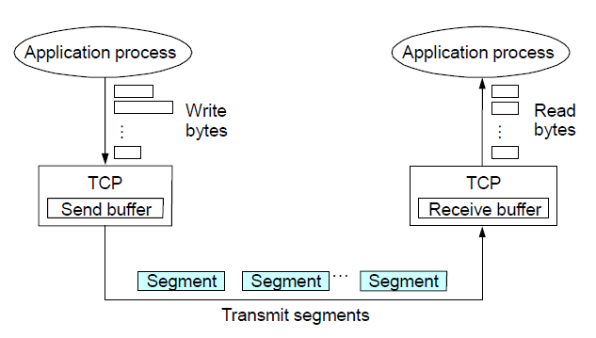

TCP features:

* **Connection-oriented:** TCP establishes a connection between the sender and receiver before data can be transmitted. This connection is set up using a **three-way handshake** process (SYN, SYN-ACK, ACK) to ensure that both parties are ready for data transfer.
* **Full-duplex communication**, allowing data to be sent and received simultaneously between two endpoints.
* **Reliable Delivery**: it guarantees that data sent from one end is received correctly by the other end, ensuring that lost packets are retransmitted, and data is delivered in correct order.
* **Byte Stream Orientation**: TCP treats data as a continuous stream of bytes, rather than discrete packets. Applications write data in **bytes** to the TCP layer, and TCP transforms this byte stream into manageable chunks (segments) for transmission.
* **Flow-control:** flow control mechanisms in TCP prevent the sender from overwhelming the receiver with too much data too quickly. TCP uses a **sliding window protocol** where the sender can only send a certain amount of data (the size of the window) before needing an acknowledgment from the receiver. If the receiver's buffer is nearing its capacity, it can inform the sender to slow down or stop sending data until it has processed some of the received data.
* **Congestion Control:** helps manage the overall data traffic in the network to prevent packet loss and ensure efficient transmission.

Traditional TCP protocols, although highly effective in wired network environments, encounter **several performance challenges in wireless scenarios**. This is largely due to the unique characteristics of wireless networks, which include higher packet loss rates primarily caused by interference and signal degradation, leading to reduced data integrity and retransmissions. Moreover, wireless networks experience variable latency as network conditions fluctuate, affecting the consistency of data transfer rates. Furthermore, these protocols are not well-optimized for managing bursty data flows, which are common in wireless networks. These inefficiencies can significantly impact the overall performance of TCP over wireless connections, highlighting the need for adaptive solutions tailored for wireless environments.

**RELIABILITY**

In TCP, reliability is a critical feature designed to ensure that data is delivered accurately.

* **Checksum for error detection:** each TCP segment includes a checksumin its header, the checksum is used to detect any bit-level errors that may occur during transmission. f the receiver detects that the checksum does not match the data, it discards the segment and expects the sender to retransmit it.
* **Sequence number used for Sequencing and Duplicate Detection:** sequence numbers are assigned to each byte in the data stream. Each TCP segment includes the sequence number of the first byte in that segment. These sequence numbers help the receiver put the incoming segments back in the correct order. If packets are lost, reordered, or duplicated during transmission, TCP can detect and handle those errors by retransmitting the lost packets and reordering the out-of-sequence packets.
* **Packet loss and Retransmission:** TCP uses **timeouts** to detect packet loss. If the sender does not receive an acknowledgment (ACK) for a packet within a certain period (known as the RTO, or Retransmission Timeout), it assumes the packet was lost and retransmits it.
* **Duplicate Acknowledgment:** TCP can also detect packet loss through a faster mechanism known as duplicate acknowledgment. If the receiver notices a gap in the sequence of received segments (e.g., packet loss), it sends duplicate ACKs for the last correctly received packet. When the sender receives **three duplicate ACKs**, it interprets this as an indication that a packet has been lost and immediately retransmits the lost segment without waiting for the RTO. This process is part of **TCP's Fast Retransmit mechanism**.

**TIMEOUT-BASED RECOVERY**

A crucial part of this mechanism is determining the appropriate Retransmission Timeout (RTO). If a packet is not acknowledged within the calculated RTO, TCP assumes it has been lost and retransmits it. The challenge lies in accurately determining this timeout period.

**Round Trip Time (RTT)** is the time it takes for a packet to travel from the sender to the receiver and for the acknowledgment (ACK) to come back. TCP needs to wait for at least one RTT before deciding whether to retransmit a packet. This ensures the sender does not unnecessarily retransmit packets that may just be delayed in the network. **RTT Estimation is crucial for determining the right RTO**. If the RTO is set too low, TCP will retransmit too quickly, causing unneeded retransmissions. If the RTO is set too high, TCP will wait too long to retransmit, leading to poor throughputas lost packets are not detected and retransmitted quickly enough.

The RTO should change as the RTT changes (e.g., when the network becomes more congested or less congested). However, the adaptation should not be too fast(which could cause instability), nor too **slow** (which could cause poor performance). A commonly used heuristic is to set the RTOto be about 4 times the current estimated RTT.

**FAST RETRANSMIT**

The key idea is to take advantage of **duplicate acknowledgments (dupacks)** as a signal for potential packet loss. A dupackis an acknowledgment (ACK) that is sent for the same data segment multiple times. Normally, TCP sends an ACK for each segment it receives. If a segment is lost, the receiver continues to acknowledge the last segment it received in sequence. This results in multiple duplicate ACKs for the same segment.

For example, if the sender sends packets 1, 2, 3, 4, and packet 2 is lost, the receiver would ACK packet 1 again (3 times 🡪 **dupack**) after receiving packets 3 and 4 (since it is still waiting for packet 2). Duplicate ACK’s can occur when a packet is lost, when packets need reordering or if the flow control window has changed.

TCP assumes that **packet re-ordering** is infrequent and not significant enough to cause more than a couple of dupacks. Hence, TCP waits until it receives **three duplicate ACKs** (four ACKs total) for the same data segment before assuming packet loss.

**FAST RETRANSMIT AND FAST RECOVERY: 3 DUPACKS**

Problem: **Coarse-grained TCP timeouts lead to idle periods**. When packet loss occurs and TCP relies on a timeoutto retransmit the lost packet, the sender remains idle during this waiting period. This can lead to poor performance, especially when the timeout is too high. **Fast retransmit** and **fast recovery** are mechanisms designed to improve performance by reducing idle time and allowing quicker recovery from packet loss.

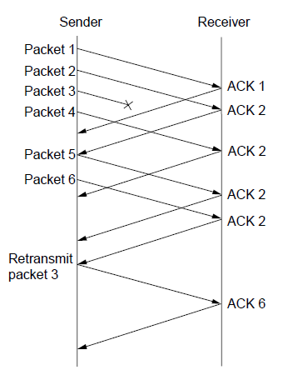**Fast Retransmit** has been explained previously, it uses 3 duplicate ACKs (dupacks) to trigger retransmission.

**Fast Recovery** is used to prevent TCP from drastically reducing its sending rate after fast retransmit. After a packet loss is detected and 3 dupacks are received TCP performs a fast retransmit of the missing packet, bypassing the normal timeout procedure. Then is set the **ssthresh value** (slow start threshold).Then the sender sets the congestion window (cwnd) to ssthresh instead of dropping the congestion window to 1 segment, as happens after a timeout. After the lost packet is retransmitted, TCP does not stop sending packets altogether. Instead, it sends **ssthresh new packets** to keep the network busy and continue the transmission. TCP continues with **additive increase** (increasing the window linearly) until the network recovers and normal transmission resumes.

Note: congestion window represents the maximum number of packets that is possible to transmit without having received the corresponding ACK yet (in the previous example the congestion window was 4, after that number I want to get the ACKs). The congestion window over the RTT determines the transmission bandwidth.

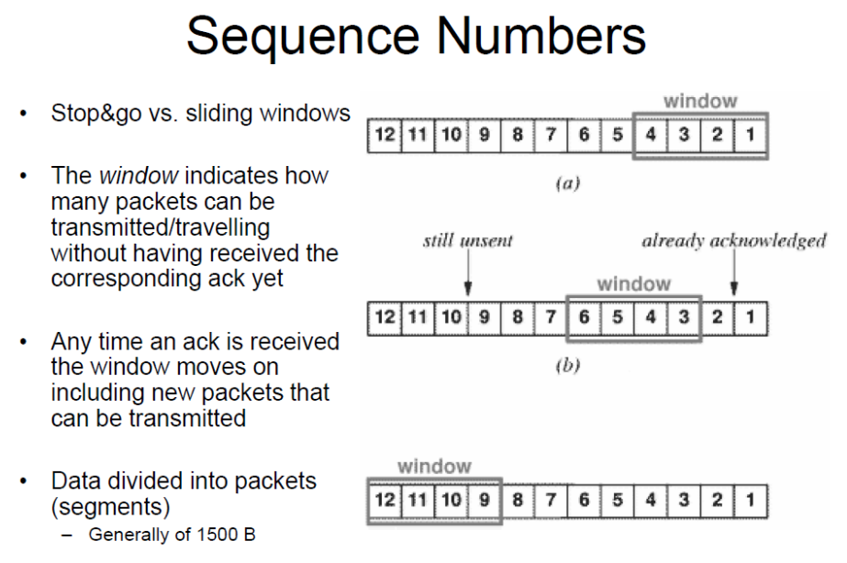

In **stop-and-go protocols** (like Stop-and-Wait), the sender transmits one packet and waits for

an acknowledgment (ACK) before sending the next packet.

**Sliding window** is a more efficient method, allowing multiple packets to be "in flight" (i.e., transmitted but not yet acknowledged).

TCP assigns a sequence number to every bite of data in the data stream. If the sender sends a segment starting with byte 1000, and the segment contains 1000 bytes of data, the next segment will start with sequence number 2000, and so on. The receiver sends an ACK with the sequence number of the next expected byte. For example, if the receiver successfully receives bytes 1000 to 1999, it will send an ACK for sequence number 2000, indicating that it is expecting the next byte to start at 2000.

**TCP Flow Control** is a mechanism designed to prevent the sender from overwhelming the receiver with too much data at once. The receiver maintains a **receive buffer**, which temporarily holds incoming data before the application on the receiver side processes it.

The **Advertised Window** is a field in the TCP header of the ACKpackets sent back to the sender. It indicates the amount of buffer space available for receiving more data.

The senderhas a **Sending Window**, which limits how much data it can send before needing an acknowledgment from the receiver. The Sending Window is the minimum of two values: sender’s computed congestion window and advertised window.

**Delay-Bandwidth Product** is a measure of the capacity of network path between sender and receiver. It represents the maximum number of data that can be traveling on the link at any time, similar to the amount of water filling up a pipe.

* **Delay (or Latency/RTT)**: the time taken for data to travel from sender to receiver.
* **Bandwidth**: the data-carrying capacity of the link (usually measured in bits per second).
* **Delay x Bandwidth** represents the total amount of data that can occupy the link at any given time.

**TCP CONGESTION COTROL**

Congestion control is **designed to prevent the sender from overloading the network**. TCP operates under the assumption that network devices are “best-effort”routers, meaning they forward packets in a First In-First-Out (FIFO)order without guaranteeing any quality of service. Each TCP source dynamically determines the network’s capacity by observing how quickly acknowledgments (ACKs) return. The ACKs serve as **implicit feedback on the network's congestion state**. The ACKs"pace" the data transmission, essentially acting as a self-clockingmechanism. When the network is less congested, ACKs return faster, allowing the sender to increase its transmission rate.

The **Additive Increase, Multiplicative Decrease (AIMD)** mechanism in TCP congestion control allows TCP to adapt its sending rate based on network conditions. AIMD aims to adjust TCP’s CongestionWindow (CWND)size to reflect the changing available capacity in the network (recall SendingWindow = MIN(Congestion Window, AdvertisedWindow)).

AIMD idea is to **increase CongestionWindow when congestion goes down and decrease it when congestion goes up**.

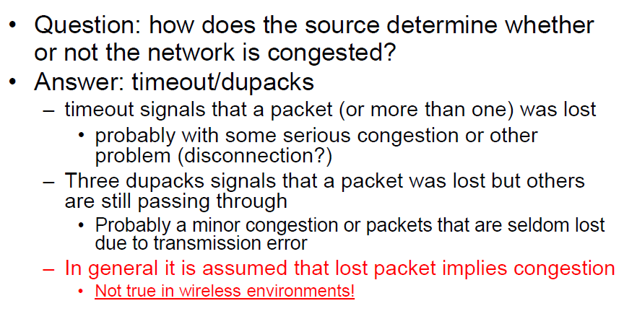

**AIMD algorithm**

1. **Additive Increase (Linear Growth):** increases the CongestionWindow by one packet per Round-Trip Time (RTT). This means that **each RTT without congestion** will result in a slightly larger CWND, **gradually allowing more packets in flight**. In practice, this increase happens progressively with each acknowledgment (ACK) received, rather than waiting a full RTT to adjust CWND.
2. **Multiplicative Decrease (Fast Reduction):** if congestion is detected (e.g., by a timeout or receiving three duplicate ACKs), the CongestionWindow is cut in half to quickly reduce the sending rate, thereby relieving network congestion.

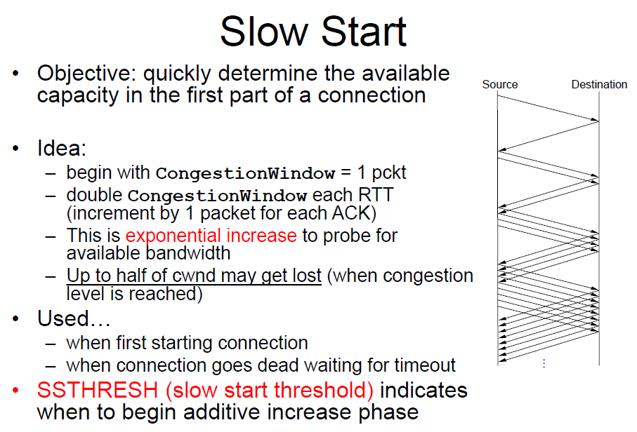

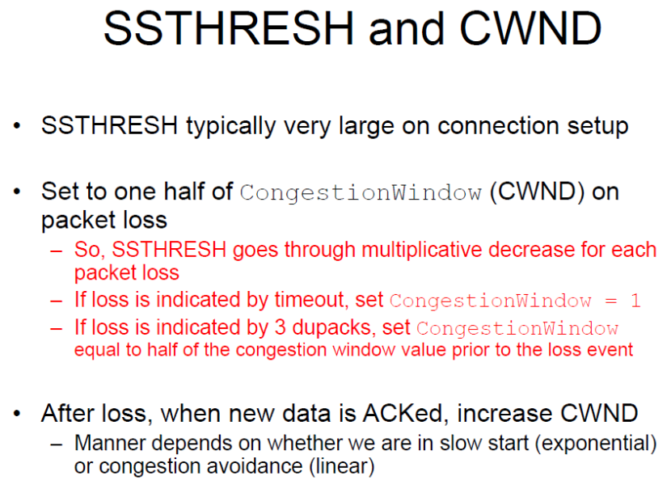

SSTHRESH is a key parameter used in congestion control to determine whether the connection should be in slow start mode or congestion avoidance mode. At the beginning cwnd is equal to 1 (slow start mode), once it reaches ssthresh value TCP switches to congestion avoidance mode using AIMD algorithm to control congestion on the network.

**Legacy TCP versions**: TCP Tahoe; TCP Reno; TCP New Reno; TCP SACK, TCP Vegas.

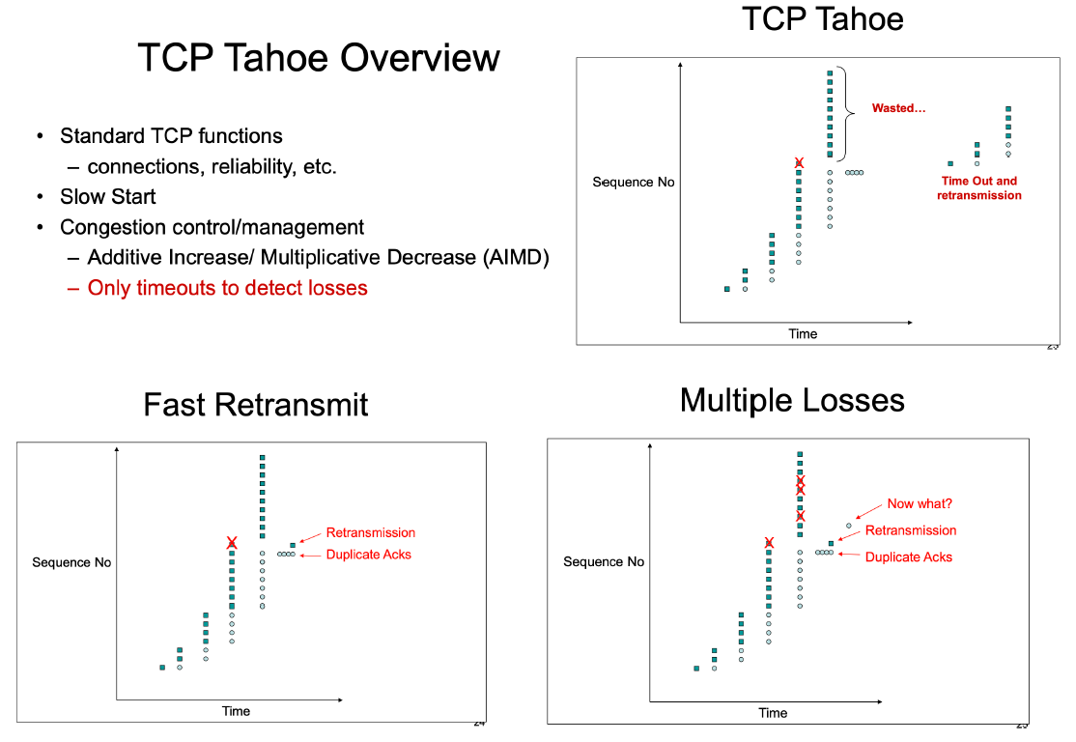

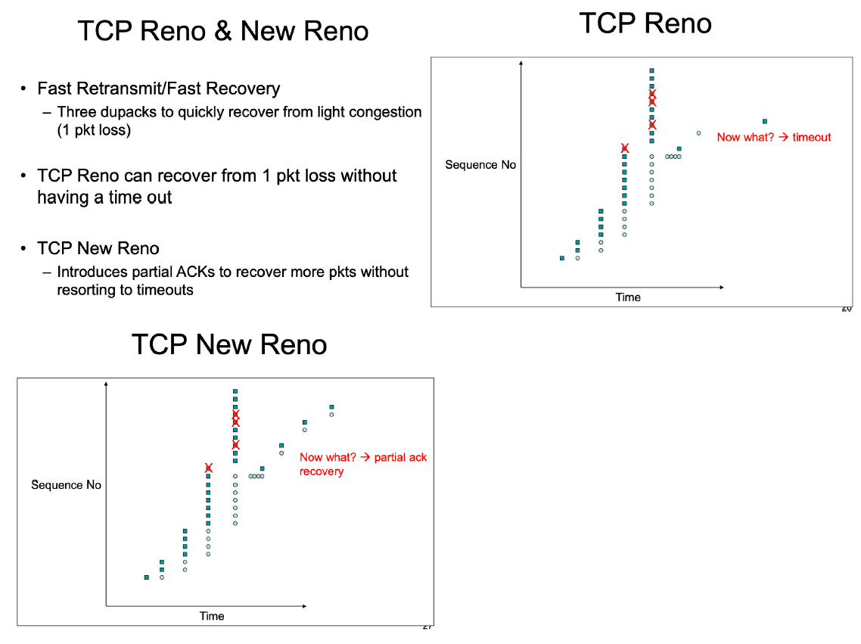

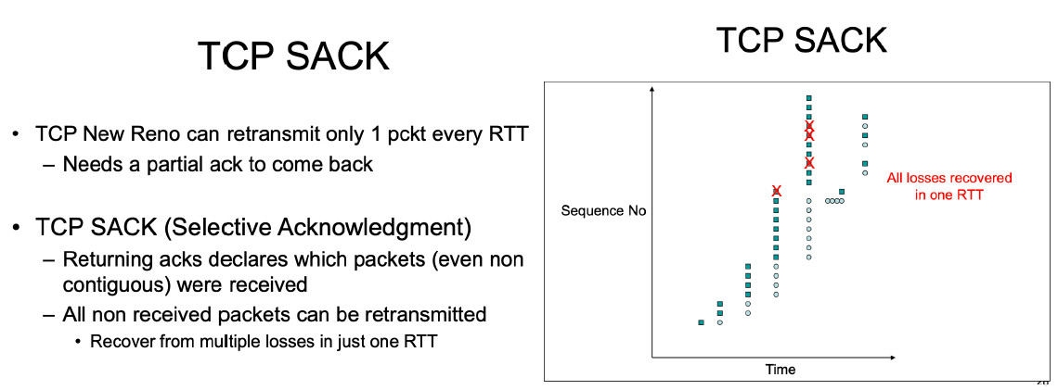

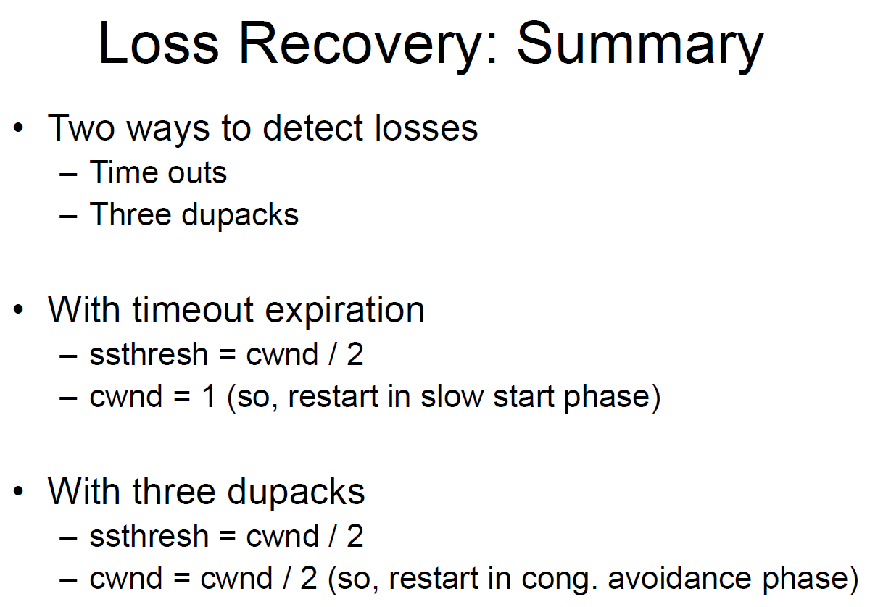

**TCP Saw Tooth**

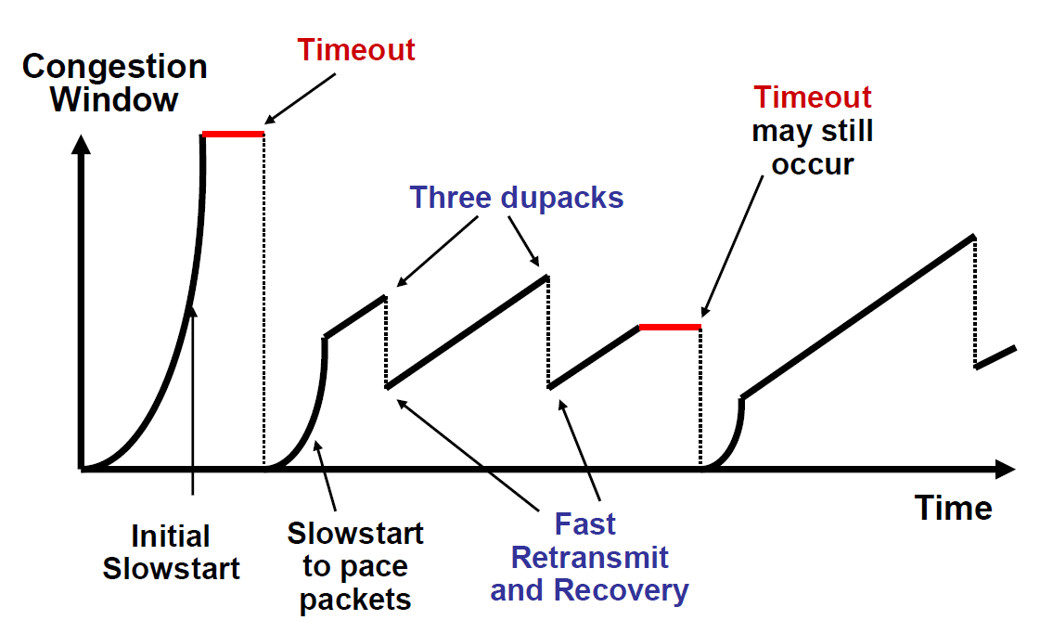

WNMA07 32/45